  All the Tendencies are respected as part of the Great Cause.  Why Join this Fight?  We are faced with end-stage capitalism in decay, & for too long the working class has allowed itself to be divided by the rich along petty lines. United, we can take back what is ours!  - A space for comradery & unity.  - Monthly events outlining methods of resistance & strategy.  - Classes on Revolutionary Theory.  - The Chance to create a real democracy, where we all have a voice.  - Community resources & outreach.
  Who We Are
  About Us
  We seek to unite the anti-capitalist elements of Kansas to present a united front against the rising tide of fascist oppression held up by both of the traditional political parties.
  Contact Us
  Phone: Coming Soon
  Email: ContactUs@KCA.org
  www.KansasCommunistAssociation.org
  
  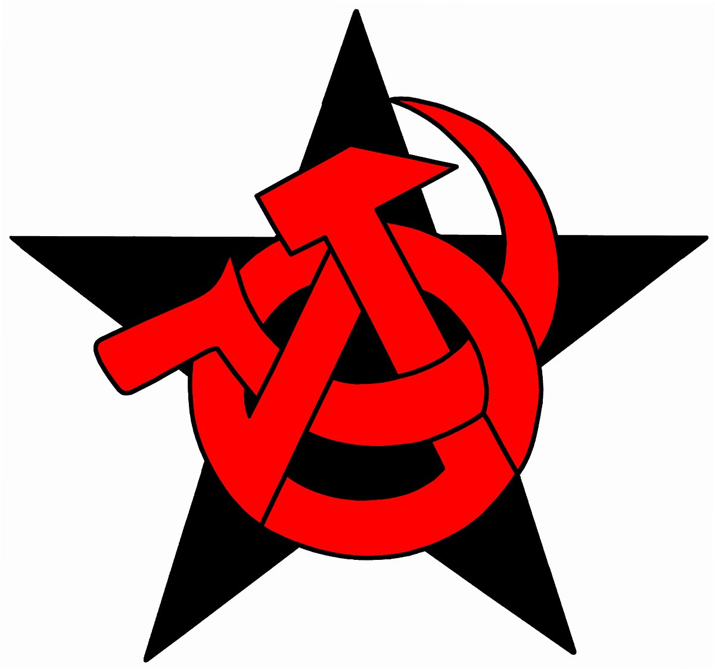 | Kansas Communist Association  Wichita, KS. 67218  ContactUs@KCA.com
  
  Kansas Communist Association
    - A United Association of Kansas Anti-Capitalists
  Join in the history of Kansas Radicalism & stand against oppression.  Events  We will teach you the art of resistance…  Every month, our allies & we have events & workshops in which you can learn the strategy & methods of resisting the increasing oppression of capitalist forces. This includes book reading, range days, & workshops where we put together the tools needed to stand against the ruling class.  - Monthly readings  - Praxis workshops  - Book fairs  - Weekly Protests  - Social Events | Who we are…  We are an alliance of anti-capitalist groups & individuals, including members of many of the existing national parties & organizations such as the FPICT, CPUSA, PSL, Anarchist Collectives, & DSA.  All cultures, creeds, or identities are welcome as long as they stand firm against capitalism & the fascist forces that uphold it.  “ONLY IN COMMUNITY WITH OTHERS HAS EACH INDIVIDUAL THE MEANS OF CULTIVATING HIS GIFTS IN ALL DIRECTIONS; ONLY IN THE COMMUNITY, THEREFORE, IS PERSONAL FREEDOM POSSIBLE.”  – Karl Marx  What we do…  We use all methods of resistance, including praxis, community outreach, & propaganda to bring awareness of the cause to the working masses. |   Not one step back!  Our Positions…  We stand firm & united against the ruling classes’ attacks on our freedom. Meaning:  - Anti-Capitalism  - True democracy where we each have an equal say.  - Anti-Zionism & the 1-state solution.  - Anti-Colonialism  - Renewable energy  - Publically funded Healthcare for all people.  - Publically funded Education at all levels

